**Assignment 5.3:**

**Problem Statement**: Implement the use case present in below blog link:

<https://acadgild.com/blog/pig-use-case-pokemon-data-analysis/>

Used Files:

* Pokemon.csv

**Ques 1: Find the list of players that have been selected in the qualifying round (DEFENCE>55).**

selected_list = FILTER Load_Data BY Defense>55;

DUMP selected_list;

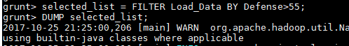

**Ques 2: State the number of players taking part in the competition after getting selected in the qualifying round.**

gourp_selcted_list = Group selected_list All;

count_selcted_list = foreach gourp_selcted_list GENERATE COUNT(selected_list);





**Ques 3: Using random() generate random numbers for each Pokémon on the selected list.**

random_include1 = foreach selected_list GENERATE RANDOM(),Name,Type1,Type2,Total,HP,Attack,Defense,SpAtk,SpDef,Speed;

DUMP random_include1;



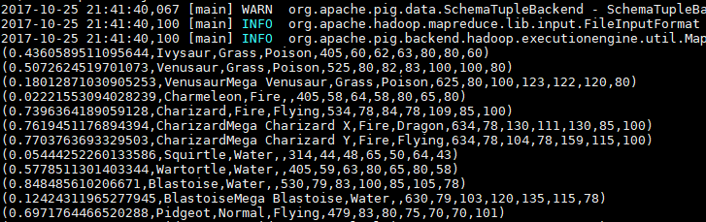

**Ques 4: Arrange the new list in a descending order according to a column randomly.**

random1_desending = ORDER random_include1 BY $0 DESC;



DUMP random1_desending;

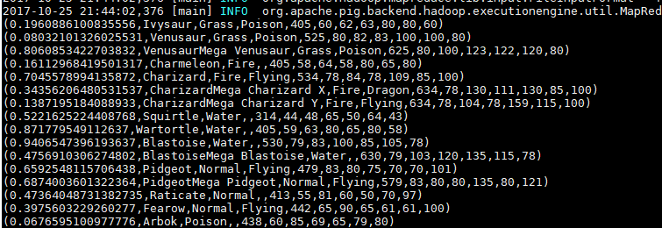

**Ques 5: Now on a new relation again associate random numbers for each Pokémon and arrange in descending order according to column random.**

random_include2 = foreach selected_list GENERATE RANDOM(),Name,Type1,Type2,Total,HP,Attack,Defense,SpAtk,SpDef,Speed;



random2_desending = ORDER random_include2 BY $0 DESC;



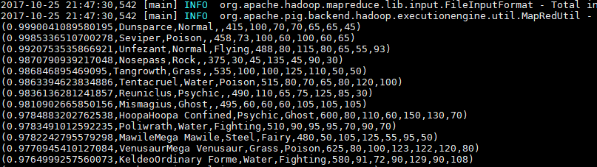

**Ques: From the two different descending lists of random Pokémons, select the top 5 Pokémons for 2 different players.**

limit_data_random1_desending = LIMIT random1_desending 5 ;

DUMP limit_data_random1_desending;

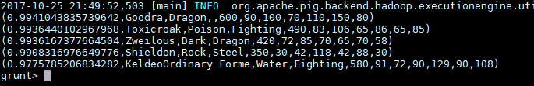

limit_data_random2_desending = LIMIT random2_desending 5 ;

DUMP limit_data_random2_desending;

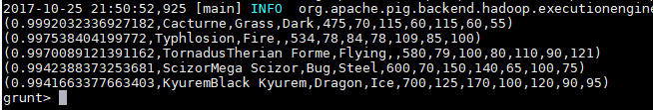

**Ques: Store the data on a local drive to announce for the final match. By the name player1 and player2 (only show the NAME and HP).**

filter_only_name1 = foreach limit_data_random1_desending Generate ($1,HP);

DUMP filter_only_name1;

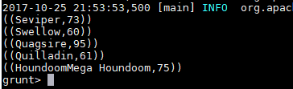

filter_only_name2 = foreach limit_data_random2_desending Generate ($1,HP);

DUMP filter_only_name2;

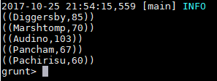

STORE limit_data_random1_desending INTO ‘/home/acadgild/pig/player1.txt’;





